Rail corridor to boost S-E Asia-west China trade links

When ready, Southern Transport Corridor will provide more direct route between the two regions

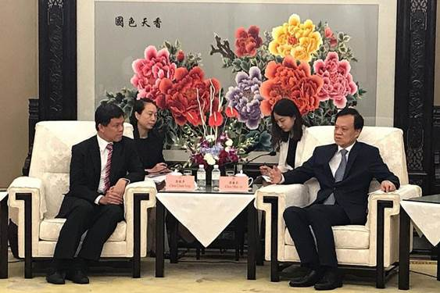

Mr Chan Chun Sing meeting Mr Chen Min'er, Chongqing party chief, in the Chinese city yesterday. The two discussed ways to deepen collaboration over the Chongqing Connectivity Initiative, a Singapore-China joint project to boost regional links.

A network of railways linking Chongqing to Guangxi is set to provide a shorter and more direct trade route between western China and South-east Asia.

This was the focus of discussions at an annual meeting yesterday under the Chongqing Connectivity Initiative (CCI), a joint project between Singapore and China to boost regional links.

When ready, the network, known as the Southern Transport Corridor, will link the south-western city of Chongqing and neighbouring Guangxi, Guizhou and Gansu to both the overland and sea routes of China's ambitious Belt and Road Initiative.

It could be a more cost-effective way for companies in South-east Asia to go into western China, via Guangxi's Qinzhou port at Beibu Gulf (the Gulf of Tonkin). The new rail corridor can further link the companies up to Central Asia and Europe via the Chongqing-Xinjiang-Europe railway.

"The Southern Transport Corridor... is a key milestone project," Singapore's Minister in the Prime Minister's Office Chan Chun Sing said at the Third CCI-Joint Implementation Committee Meeting.

He cited how it now takes three weeks to transport a 20ft container from Singapore to Chongqing via a sea route through Shanghai, followed by river transportation along the Yangtze River.

With the new Southern Transport Corridor, this can be done in a week - five days by sea from Singapore to Beibu Gulf, and less than two days to Chongqing.

Chongqing Mayor Zhang Guoqing, who co-chaired the meeting with Mr Chan yesterday, said: "The (railway network along) the Southern Transport Corridor is already in place. But there are many obstacles. We will try our best to lower the transport and logistic costs, improve the ease of clearing Customs and its operational efficiency."

KEY PROJECT

**The Southern Transport Corridor... is a key milestone project.**

SINGAPORE'S MINISTER IN THE PRIME MINISTER'S OFFICE CHAN CHUN SING

Yesterday, Mr Chan also met new Chongqing party chief Chen Min'er, a rising political star who is known to be close to Chinese President Xi Jinping.

Mr Chen had replaced Mr Sun Zhengcai in July after the latter was abruptly removed and placed under investigation for "serious violations of party discipline".

During the meeting, Mr Chan and Mr Chen discussed ways to deepen collaboration to achieve the joint project's aims.

The project was launched during Mr Xi's visit to Singapore in November 2015 as the third government-to-government project after the Suzhou Industrial Park and the Tianjin Eco-city.

It aims to boost growth in China's less-developed western regions and support the Belt and Road Initiative, a plan to revive ancient trade routes linking Asia, Africa and Europe to boost global commerce.

The project also serves as a platform for younger leaders from both sides to work together.

Mr Chen, formerly party chief of Guizhou province, said: "I've paid attention to the CCI from the very start of the discussions. Now that I'm in Chongqing, I will pay greater attention to the project, and I will get to appreciate the importance of the project to the strategic cooperation between the two countries."

He said that in the 40 or so days since he arrived in Chongqing, he has seen a high level of attention and support given to the project by the city's government, people and neighbouring provinces.

Describing the project as visionary, Mr Chen said: "It is a win-win strategic cooperation at the country level, different from any other individual cooperation projects."

Mr Chan, in China on an official visit from Wednesday to tomorrow, is in Guangxi today and is slated to visit southern Guizhou province tomorrow, the last day of his trip.

He will today attend the ground-breaking ceremony of the Singapore-Guangxi Integrated Logistics Park in Nanning, capital of Guangxi. He will also meet local government and party officials.

Accompanying him on the trip are Mrs Josephine Teo, Minister in the Prime Minister's Office and Second Minister for Manpower and Foreign Affairs, Mr Chee Hong Tat, Senior Minister of State for Communications and Information, and Health, as well as officials from ministries and statutory boards

+++ End +++